भारत मौसम विज्ञान विभाग |  | India Meteorological Department
Tuesday 12th May 2026 (22nd Vaisakha 1948 Saka)
Summary of observations recorded at 0830 hours IST: Conditions are becoming favourable for onset of southwest monsoon likely over parts of south Bay of Bengal, Andaman sea and Andaman & Nicobar Islands towards the end of this week. The low-pressure area over Southwest Bay of Bengal off north Sri Lanka coast moved nearly northwards and lay over southwest Bay of Bengal at 0530 Hrs IST of today, the 12th May 2026, It lay over the same region at 0830 hrs IST of today, the 12th May 2026, with the associated cyclonic circulation extending upto 4.5 km above mean sea level. It is likely to become more marked during the next 48 hours. The trough in easterlies from the centre of low pressure area over Southwest Bay of Bengal off north Sri Lanka coast to south Lakshadweep area ran from the centre of low pressure area over Southwest Bay of Bengal to Marathwada across north Tamil Nadu, Rayalaseema, North Interior Karnataka at 0.9 km above m. s. l. The Western Disturbance as an upper air cyclonic circulation over North Pakistan & neighbourhood at 3.1 km above m. s. l. persisted. The upper air cyclonic circulation over West Rajasthan & neighbourhood persisted and seen at 0.9 km above m. s. l. The upper air cyclonic circulation over Southwest Madhya Pradesh & neighbourhood and extended upto 1.5 km above m. s. l. persisted. The trough from upper air cyclonic circulation over Southwest Madhya Pradesh to Sub Himalayan West Bengal ran from upper air cyclonic circulation over Southwest Madhya Pradesh to Manipur across East Madhya Pradesh, Chhattisgarh, Jharkhand & Gangetic West Bengal and extends upto 0.9 km above m. s. l. The trough from East Arunachal Pradesh to North Bay of Bengal ran roughly along Long. 93°E to the north of Lat. 22°N. A fresh Western Disturbance is likely to affect Northwest India from 15 May 2026. An upper air cyclonic circulation lay over North central Uttar Pradesh & neighbourhood at 1.5 km above m. s. l. An upper air cyclonic circulation lay over South Interior Karnataka & neighbourhood at 5.8 km above m. s. l. The trough in easterlies from the cyclonic circulation over Southeast Arabian Sea & adjoining Lakshadweep adjoining Kerala coast to Marathwada became less marked. The upper air cyclonic circulation over Sub-Himalayan West Bengal & neighbourhood between 1.5 & 3.1 km above m. s. l. became less marked. The upper air cyclonic circulation over South Assam & neighbourhood became less marked. The upper air cyclonic circulation over Southeast Arabian Sea & Lakshadweep adjoining Kerala coast became less marked at 0530 hrs IST of today.
Maximum Temperature Departures (as on 11-05-2026): markedly above normal (> 5.1°C) at many places over West Rajasthan and East Rajasthan; at most places over Gujarat Region; at few places over Jammu-Kashmir Ladakh Gilgit-Baltistan-Muzaffarabad and Marathwada; at isolated places over West Madhya Pradesh, East Madhya Pradesh, Saurashtra & Kutch, Konkan & Goa, Madhya Maharashtra, Vidarbha and Chhattisgarh. appreciably above normal (3.1°C to 5.0°C) at few places over Haryana-Chandigarh-Delhi, Punjab and Himachal Pradesh; at isolated places over Sub Himalayan West Bengal & Sikkim, Coastal Andhra Pradesh & Yanam and Telangana. above normal (1.6°C to 3.0°C) at few places over West Uttar Pradesh, Coastal Karnataka and North Interior Karnataka; at isolated places over Assam & Meghalaya, Gangetic West Bengal, Odisha, Bihar and Tamil Nadu, Puducherry & Karaikal. near normal (-1.5°C to 1.5°C) at many places over Uttarakhand; at most places over Andaman & Nicobar Islands, Arunachal Pradesh, East Uttar Pradesh, Rayalaseema, South Interior Karnataka, Kerala & Mahe and Lakshadweep; at few places over Nagaland, Manipur, Mizoram & Tripura; at isolated places over Jharkhand. The highest maximum temperature of 47.3°C was reported at BARMER (RAJASTHAN).

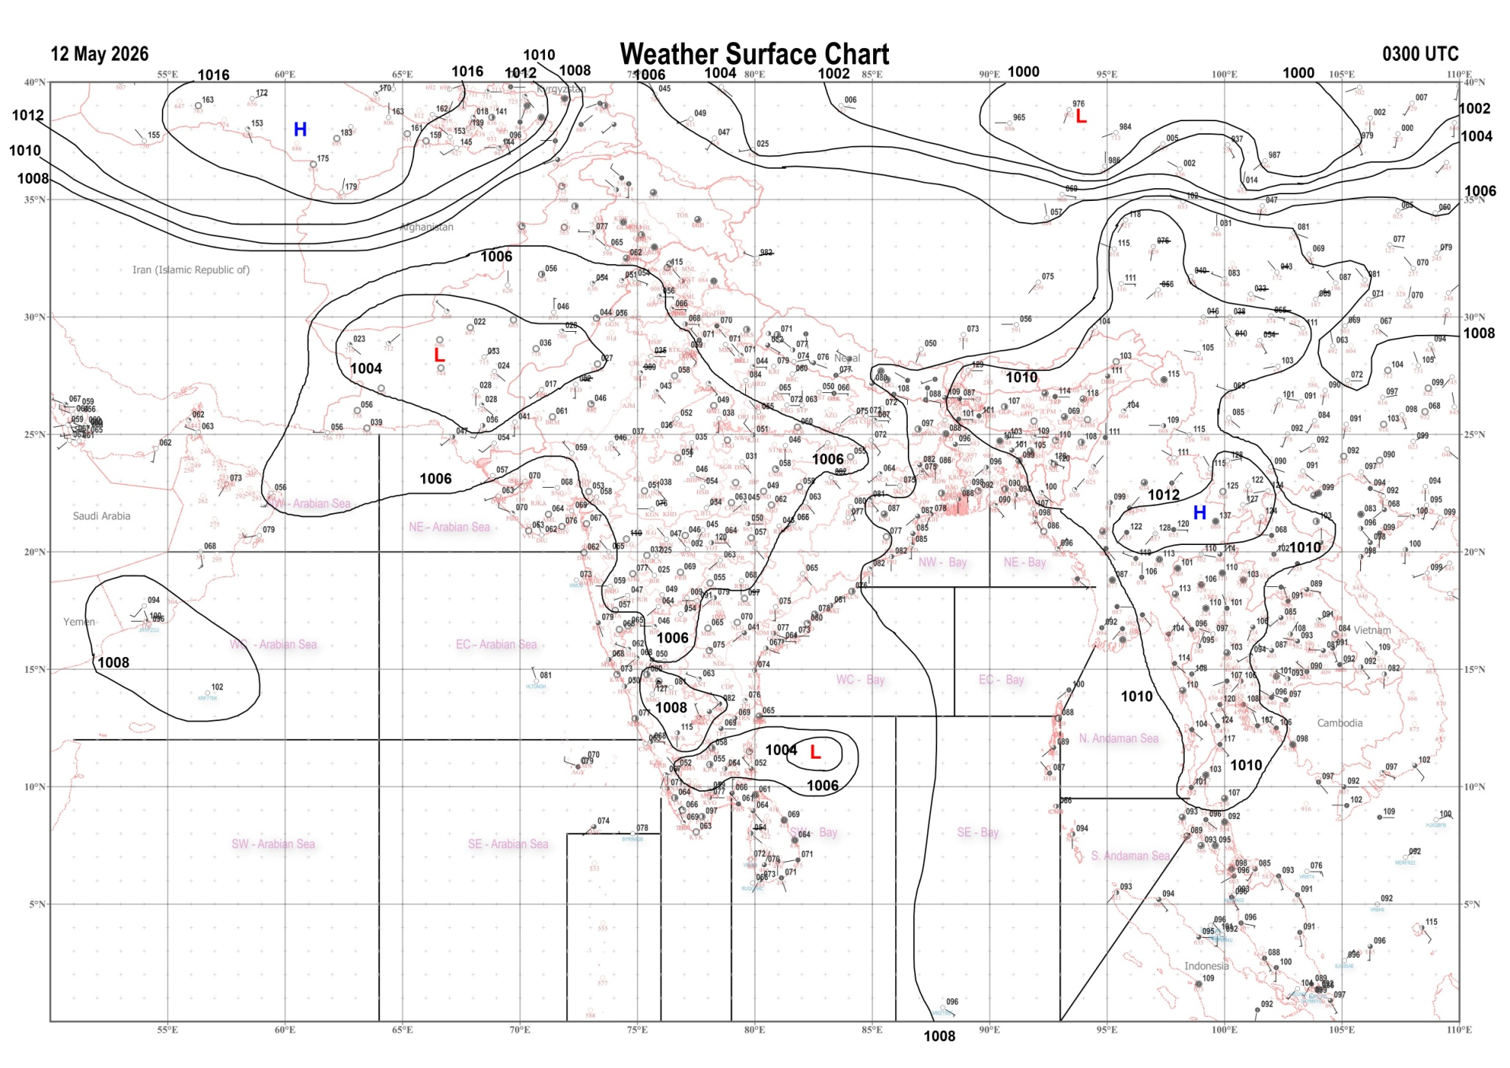 | 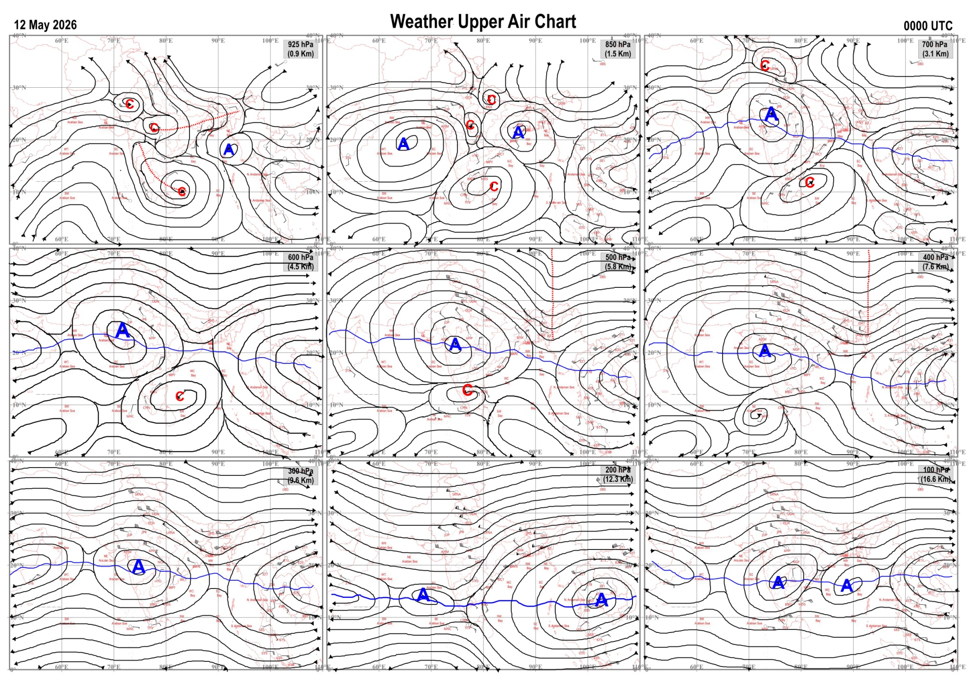
Fig.1. Analysed surface chart based on 03z observation | Fig.2. Analysed upper air chart based on 00z observation
CR & S Office, Pune  Issued at 1245 hrs. IST |  | Weather Forecasting Division  CR&S, Pune

Indian regions | Realised rainfall (chief amount in cm during past 24 hrs):
East | many places: Sub-Himalayan West Bengal & Sikkim+  a few places: Arunachal Pradesh, Assam & Meghalaya+ and Nagaland-Manipur-Mizoram-Tripura  isolated places: Gangetic West Bengal◆, Odisha, Jharkhand and Bihar  Hazuah 8.5, Washabari tea estate 7.2, Bagdogra IAF 6.4, Zurrantee t.e 6.3, Byrnihat ARG 5.3, Akhuapada 4.6, Ramgarh (bdo) 4.5, Tilaiya dvc 3.9, Jenapur 3.5, Lengpui 3.4, Kanchanpur 3.1, Tamenglong 3.0, Amaur 2.6, Thakurganj 2.4, Bomdila 2.0, Bhalukpong & Mawsynram 1.6 each, Seppa 1.2, Keonjhargarh 0.5, Forbesganj 0.2, Mo saltlake 0.1.
North | many places: Jammu-Kashmir and Ladakh  isolated places: west Uttar Pradesh◆, Uttarakhand, Haryana, Punjab, Himachal Pradesh and west Rajasthan  dry weather: east Uttar Pradesh and east Rajasthan  Didihat 2.9, Chamoli 2.6, Nowgam 1.7, Saloni & Lolab 1.5 each, Badarwah 1.4, Bharmaur 1.2, Joshimath & Moga 1.0 each, Dav chandigarh AWS, Zira & Bhadra 0.5 each, Chandigarh, Naraingarh & Keylong 0.4 each, Sardhana 0.1.
Central | dry weather: Madhya Pradesh, Vidarbha and Chhattisgarh
Peninsula | a few places: Kerala  isolated places: coastal Andhra Pradesh, Telangana, Rayalaseema, Tamil Nadu, coastal Karnataka and interior Karnataka  dry weather: Gujarat State, Konkan & Goa, Madhya Maharashtra and Marathwada  Aliyar & Taliparamba 4.7 each, Pamban 4.4, Mudubidre & Cheruvanchery AWS 3.1 each, Haveri PTO & Kalasa 3.0 each, Ponnampet PWD 2.2, Upasi tea research AWS 1.9, Kochi IAF 1.6, Aswaraopeta & Kiravatti 1.3 each, Balehonnur 1.2, Paderu 1.1, Shirahatti 1.0, Kalghatgi 0.8, Chintalapudi & Owk 0.6 each, Banaganapalle 0.4, Mangaluru AP 0.3.
Islands | most places: Andaman & Nicobar  dry weather: Lakshadweep  Hut bay 3.8, Car Nicobar & Port blair 2.7 each
Table-2 Forecast / warnings (distribution of rain / thundershowers) for 7 days (valid from time of origin upto 0830 hrs IST of next day)
Sr N. |  | Sub-division Name | Day 1 | Day 2 | Day 3 | Day 4 | Day 5 | Day 6 | Day 7 | Sr. No. | Sub-division Name | Day 1 | Day 2 | Day 3 | Day 4 | Day 5 | Day 6 | Day 7
 |  |  | 12 May | 13 May | 14 May | 15 May | 16 May | 17 May | 18 May |  |  | 12 May | 13 May | 14 May | 15 May | 16 May | 17 May | 18 May
 | 1 | Andaman Nicobar Islands | F +  | W +  | W +  | W +  | W +  | W+  | W +  | 19 | west Madhya Pradesh | D + | D + | D + | D + | D + | D + | D +
 | 2 | Arunachal Pradesh | S  | F +  | F +  | F +  | W+ | W ++ | W ++ | 20 | east Madhya Pradesh | D | D | D | D | D | D | D
 | 3 | Assam-Meghalaya | F +  | W ++  | W++  | W ++  | W ++  | W ++ | W + | 21 | Gujarat region | D + | D + | D + | D | D | D | D
 | 4 | Nagaland-Manipur-Mizoram-Tripura | S | S | S + | F + | F + | F + | F + | 22 | Saurashtra and Kutch | D + | D + | D + | D | D | D | D
 | 5 | Sub Him West Bengal/Sikkim | W +  | W ++  | W +  | F  | F  | F | F | 23 | Konkan and Goa | D + | D + | D + | D | D | D | D
 | 6 | Gangetic West Bengal | S  | S  | S  | I  | I  | I | I | 24 | Madhya Maharashtra | D + | D + | D + | D | D | D | D
 | 7 | Odisha | I  | I  | I  | I  | I  | I | I | 25 | Marathwada | D + | D + | D + | D + | D | D | D
 | 8 | Jharkhand | I  | S  | I  | S  | S  | I  | I  | 26 | Vidarbha | D + | D + | D + | D + | D + | D | D
 | 9 | Bihar | I  | S  | I  | I  | I  | I | I | 27 | Chhattisgarh | D | I  | I  | I  | I  | I | I
 | 10 | east Uttar Pradesh | I  | I  | D | D | D | D | D | 28 | Coastal Andhra Pradesh and Yanam | I  | I  | I  | I  | I  | I | I
 | 11 | west Uttar Pradesh | I  | I  | D | D | D | D | D | 29 | Telangana | I  | D | D | D | D | D | D
 | 12 | Uttarakhand | F  | F  | S  | I | I | I | D | 30 | Rayalaseema | I | I | I | I | I | I | I
 | 13 | Haryana,Chandigarh and Delhi | I  | I  | I  | I | D | D | D | 31 | Tamil Nadu, Puducherry and Karaikal | I +  | I  | I + | I + | I | I | I
 | 14 | Punjab | I  | I  | I  | I | D | D | D | 32 | Coastal Karnataka | I  + | I  + | I  | I  | I  | I | I
 | 15 | Himachal Pradesh | F  | F | S  | S  | S  | I | D | 33 | North interior Karnataka | I  | I  | I  | I  | I  | I | I
 | 16 | Jammu-Kashmir and Ladakh | W  | S  | S  | I | I | D | D | 34 | South interior Karnataka | I  | I  | S  | S +  | S + | I | I
 | 17 | west Rajasthan | I + | D + | D + | D + | D + | D + | D+ | 35 | Kerala and Mahe | F  | F  | W  | W+ | W + | W | W
 | 18 | east Rajasthan | I  + | I + | D + | D + | D + | D + | D + | 36 | Lakshadweep | F  | F  | F | F | F | F | F
Legends: D = Dry I =isolated S = Scattered F = Fairly widespread W = Widespread #= heavy to very heavy rain at a few places with extremely heavy rain at isolated places+++= heavy rain at a few places with very heavy rain at isoIated places++= heavy to very heavy rainfall @=isolated exceptionally heavy rainfall+ = heavy rain ●/*= rain or snow ♦ = very light rain ≡=fog = thunderstorm with lightning =Squall / Gusty / gale / strong wind -=cold wave/cold day + = heat wave/warm night/hot and humid weather =Duststorm =ground frost = Hail.

Fig. 4: Districtwise warnings for five days for Maharashtra State
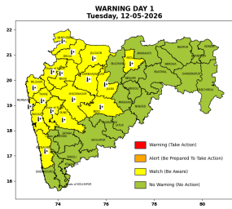 | 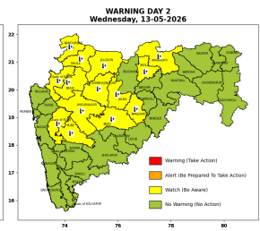 | 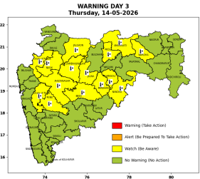 | 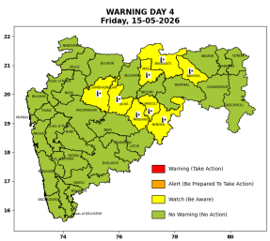 | 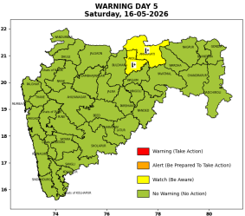

Pune, Lohegaon and Pashan observations at 0830 hrs. IST of Today
 | Temperature (°C) |  |  |  |  | Humidity (%) |  |  |  | Rainfall (mm)
 | Max.  past  24 hrs | Dep.  from  normal | Min.  past  24 hrs. | Dep.  from  normal | Dry  Bulb | At 0830 hrs. IST | Dep.  From  normal | At 1730  hrs. IST of y’day | Dep.  from  normal | Past  24 hrs. | Since  1st March | Dep.  from  normal
PNE | 41.4 | 3.4 | 24.8 | 2.5 | 32.2 | 44 | -11 | 20 | -12 | 0.0 | 92.8 | 72.3
PSN | - | - | - | - | - | - | - | - | - | - | - | -
LHG | 42.7 | 4.7 | 27.6 | 6.6 | 34.2 | 35 | -23 | 10 | -20 | 0.0 | 91.4 | 65.3

 |  |  |  |  |  |  | Local (Pune and neighbourhood) forecast
Max./Min. Temperature (°C) |  |  |  |  |  |  |  |  | Weather
Date | Pune | Pashan | Lohegaon | Chinchwad | Lavale | Magarpatta | NDA | Koregoan park
12/05/26 | 42 / 26.3* | 41 / 24.2* | 44 / 27.0* | 40 / 26.9* | 40/ 23.7* | 41 / 28.1* | 40/ 21.8* | 43 / 27.6* | Mainly clear sky becoming partly cloudy sky towards evening. .
13/05/26 | 42 / 25 | 41 / 23 | 44 / 26 | 41 / 26 | 41 / 23 | 42 / 27 | 40 / 21 | 43 / 27 | Mainly clear sky.
14/05/26 | 42 / 25 | 41 / 23 | 44/ 26 | 41 / 26 | 41 / 23 | 42/ 27 | 40 / 21 | 43 / 27 | Mainly clear sky.
15/05/26 | 41 / 24 | 40 / 22 | 43 / 25 | 40 / 25 | 40 / 22 | 41 / 26 | 39 / 20 | 42 / 26 | Mainly clear sky.
16/05/26 | 41 / 24 | 40 / 22 | 43 / 25 | 40 / 25 | 40 / 22 | 41 / 26 | 39 / 20 | 42 / 26 | Mainly clear sky.
17/05/26 | 41 / 25 | 40 / 23 | 43 / 26 | 40 / 26 | 40 / 23 | 44 / 27 | 39/ 21 | 42 / 27 | Mainly clear sky.
18/05/26 | 40 / 25 | 39 / 23 | 42 / 26 | 39 / 26 | 39 / 23 | 40 / 27 | 38/ 21 | 41 / 27 | Mainly clear sky.
Rainfall Distribution |  |  |  |  | Rainfall Categories | Rainfall (mm) | Cloud condition |  | Rainfall Intensity | Range
Widespread (W) | 76-100% |  |  |  | Very Light rain | Trace to 2.4 mm | Mainly clear sky | 1-2 oktas | Light Spell | 1 cm/hr
 |  |  |  |  | Light rain | 2.5 to 15.5 mm | Partly cloudy sky | 3-4 oktas | Moderate Spell | 1-2 cm/hr
Fairly Widespread (FW) | 51 – 75% |  |  |  | Moderate rain | 15.6 to 64.4 mm | Generally cloudy sky | 5-7 oktas | Intense Spell | 2-3 cm/hr
Scattered (S) | 26 – 50% |  |  |  | Heavy rain | 64.5 to 115.5 mm | Overcast | 8 oktas | Very Intense Spell | 3-5 cm/hr
Isolated (I) | 1 – 25% |  |  |  | Very heavy rain | 115.6 to 204.4 mm |  |  | Extremely Intense Spell | 5-10 cm/hr
Dry (D) | No Rain |  |  |  | Extremely heavy rain | ≥ 204.5 mm |  |  | Cloudburst | > 10 cm/hr
Probability Terms in %: |  |  |  |  | Heavy snow | 6.5 to 11.5 cms water equivalent of rain
unlikely | < 25 |  |  |  | Very heavy snow | 11.6 to 20.4 cms water equivalent of rain
likely | between 25 50
very likely | between 51 75
most likely | >75
* = realized temperatu
Mumbai (Colaba) |  |  |  | Nagpur (AP)
Date 2026 | T max °C | T min °C | Weather | T max °C | T min °C | Weather
12/05/26 | 34 | 27 | Mainly clear sky. Hot and Humid. | 43 | 26 | Mainly clear sky
13/05/26 | 34 | 26 | Clear sky. | 44 | 26 | Mainly clear sky
14/05/26 | 35 | 26 | Clear sky | 44 | 26 | Mainly clear sky
15/05/26 | 35 | 26 | Clear sky | 44 | 27 | Mainly clear sky. Heat Wave
16/05/26 | 34 | 25 | Clear sky | 43 | 26 | Mainly clear sky.
17/05/26 | 34 | 25 | Clear sky. | 43 | 26 | Mainly clear sky
18/05/26 | 33 | 25 | Clear sky. | 42 | 26 | Mainly clear sky

